Lab 4

Student Name
Institution Affiliations
Course
Instructor Name
Date

1) N
38
San Francisco
38 °N, 122 °W

San Luis
33 °S, 66 °W
S
Antananarivo
18°S 47°E
2) NW N NE

W E

SW SE
S

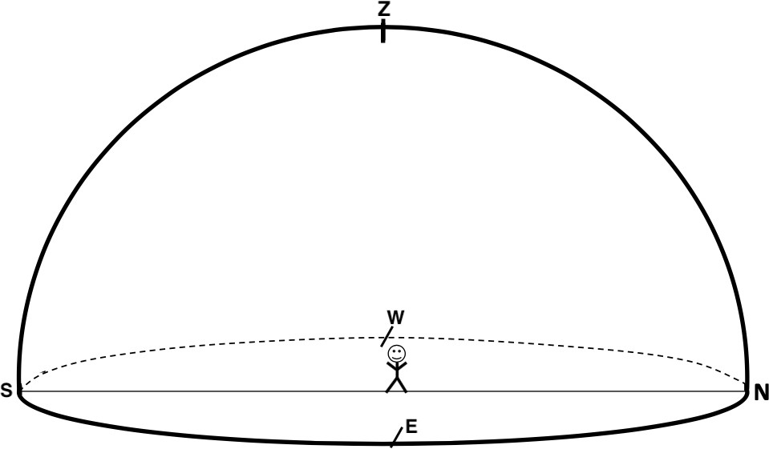
Altitude at the zenith is +90°
3) Approximate altitude of the star is +60°
4) Approximate azimuth is 45°
5) Northeast.
Part III: The Direction and Altitude of Polaris
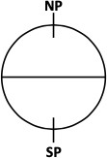
1) NCP
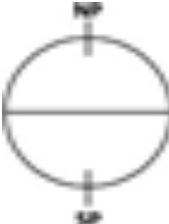

NP

SP

SCP

2) The Altitude of Polaris is +90°
Latitude of Polaris is 90°
3) The altitude of Polaris at the equator is 0°
The latitude of the observer is 0°
4) Altitude of Polaris from San Francisco is +38°
Latitude of observer is 38°
5) The altitude of Polaris is equal to the latitude of the observer.
6) a)Since the fists measures about 10° then you are on latitude 70° N
b)No it is not enough. You need the North Pole to determine the right location you are at.
7 )
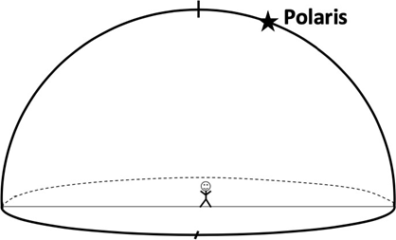N
8) Polaris
